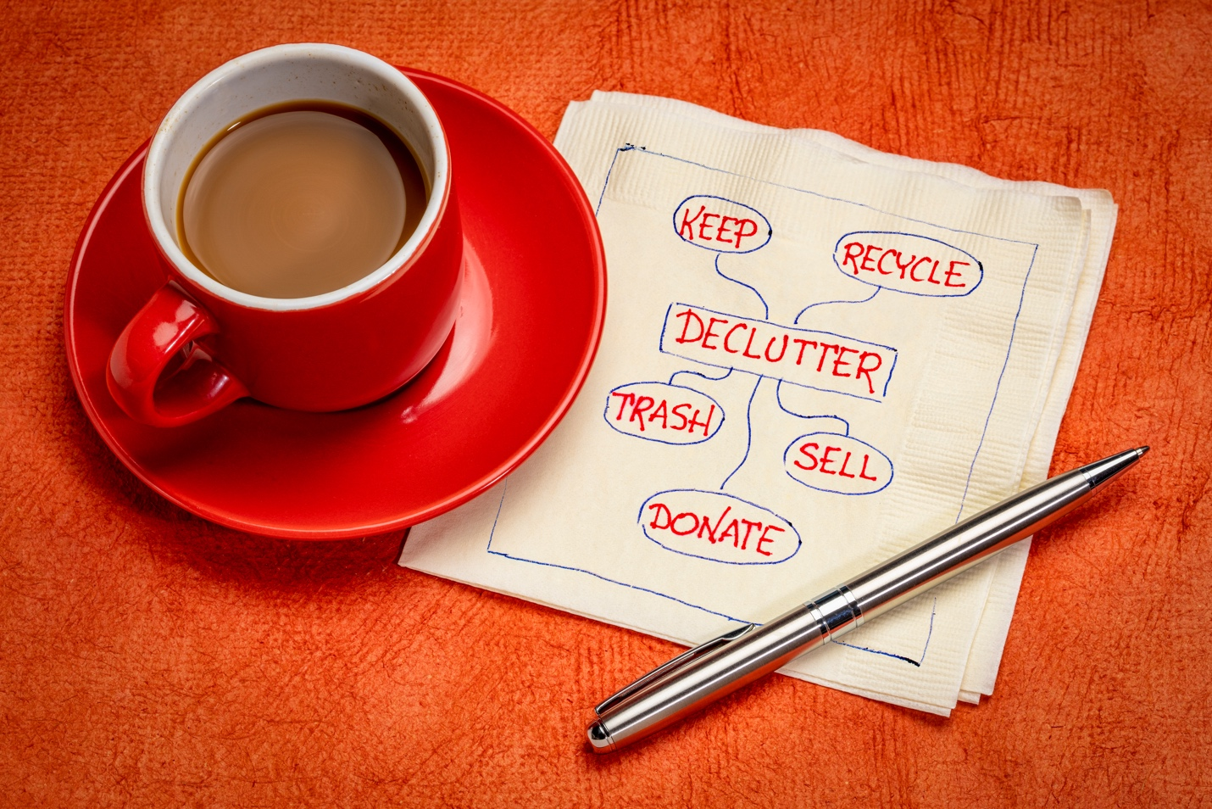

SUSTABILITY
How to make money from your unused clutter while helping the environment

Nikki Swies
Chief Revenue and Operations Officer

You’ve finally had enough of all that clutter so it’s time for a clean out! As you move through your house or apartment, you separate keep from toss until you have a huge pile of items that no longer need to take up your living space. “I have two choices for all this stuff,” you think. “I can throw it away or I can donate it.”

However, there’s another option and it’s one that is not only good for the environment but also can put some money in your pocket — utilize a pawn shop.

Pawn shops are often the unsung heroes of sustainability because they offer an opportunity to sell gently used items in good condition for cash. Those items then are resold to others at a price less than what they’d get for them if they were purchased new.

Americans throw out A LOT

According to the Environmental Protection Agency (EPA), the U.S. had 292.4 million tons of waste in 2018. That’s nearly 5 pounds of waste per person thrown into landfills each day. Can you imagine throwing away your body weight in trash multiple times each year? If you’re 152 pounds, that’s each month!

It’s not always convenient to recycle electronics. According to Earth911.com, the U.S. generated nearly 7 million tons of e-waste in 2019. In a 2019 International Telecommunications Union report, only 15 percent of potential e-waste is recycled in the U.S.

We live in a world with rapidly-evolving technology. The average lifespan of most devices is 1-2 years.
Reducing your carbon footprint by making smarter choices when it comes to purchasing can have a long-term positive impact on your community and on the planet.

Save the planet and make money
Pawn shops like EZCORP’s various stores (EZPAWN, Value Pawn, USA Pawn & Jewelry and others) procured more than 5.5 million used or pre-owned consumer product items in 2020 with a commercial value of $354 million, and resold nearly 7 million used or pre-owned items with a commercial value of $445 million during the same time frame.

When you bring in an item to sell or when you come in to purchase a pre-owned item, you’re doing a good thing for the environment. When you reuse and recycle in this way, you reduce pressure on our landfills, cutting out all the resources — both material and power — that goes into manufacturing something new.

Pawn shops pioneered the notion of a circular economy — where reusing, recycling and other refurbishment efforts minimize waste, carbon emissions and pollution. The goal is to improve our resources’ longevity and usefulness so we don’t have to keep making — and disposing — of new ones. Pawn shops are neighborhood-based stores that sell pre-owned merchandise which is sourced and then recycled within each store’s geographic area. They help to reduce the area’s carbon footprint by not selling items that directly come from manufacturing facilities or distribution centers and eliminate the need for transportation services. Pawn shops are unique, essential and sustainable.

What to take to a pawn shop
While it’s commonly known that pawn shops take electronics like computers, phones and TVs, as well as power tools and jewelry, did you know that you can take in almost anything of value that’s in good condition? Here’s a few items that make the list:

- Vacuum cleaners (must have parts)
- Kitchen appliances like air fryers and crockpots
- Sewing machines
- Single-serve coffee machines, like Keurigs
- Designer purses and handbags
- Musical instruments
- High-end shoes
- Lawn equipment
- A/C wall units
- Fancy tire rims
- Bicycles
- Strollers

Remember – the nicer or the item, the greater chance you have that a pawn shop is willing to pay for it. Do you have something brand-name? From Michael Kors to Apple to Christian Louboutin, if you have a brand that’s known for high quality, it’s worth taking it to a pawn shop for cash.

How to get top dollar
Make sure it works! Pawnbrokers are going to test it so if you try pass off something that doesn’t work or is glitchy, odds are they’ll question the authenticity of the other items you’ve brought with you.

Before you take in anything, make sure the item is clean and free of dust and debris. Remember, the newer the item looks, the greater chance you have to get a better offer! Also, bring in the manual, if you have one, as well as any accessories, parts or cords needed to use the item.

And don’t discount broken jewelry! Pawn shops often take gold and precious gems, even if the item is broken. Many will purchase your broken jewelry to be melted down or processed for other uses.

The next time you clean the clutter from your closet or garage or anywhere in your house, don’t throw your items in the trash or donate them. Make a little green and help keep your possessions out of the landfill by taking items to your local pawn shop.

Nikki Swies is the Chief Revenue and Operations Officer at EZCORP. She believes that pawn shops contribute to a circular economy where pre-owned consumer merchandise can be purchased, used and resold, extending the use and lifecycle of millions of items each year.

BLOG TAGS: Sustainability, Reuse, Pawn

